Name _________________________ Date ______________
Be sure to study the study guide for the first matter test as well as this one.
- What causes an ice cube to change into water? Heat

- After you cut a piece of paper into pieces, what state of matter are the pieces in? solid

- What causes water to turn into ice? freezing it Why is this a physical change? It is a physical change because it is reversible so it can be changed back.

- What causes water to turn into a gas? heating it

- Circle the actions below that would change the state of matter.

Bending heating cutting hiding

- Explain what is happening in this picture. The tablet is dissolving.
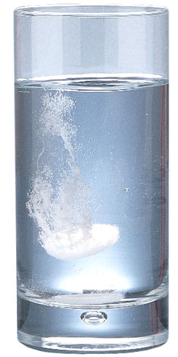

8. What are all living things made of? Matter
9. What unit is temperature measured in? degrees With what tool do I measure temperature? thermometer
10. What would I use centimeters to measure? length
11. What is the air we breathe a mixture of? gases
12. Draw a picture of a tree bending in the wind. This is a physical change.

