Measurement Study Guide Name:________________

1. Which tool would Jason use to measure the length of the playground?
2. ruler b. yardstick c. thermometer
3. What is the length of this paper clip to the nearest centimeter?

 __________________ cm

1. What is the length of the butterfly to the nearest inch? _______________

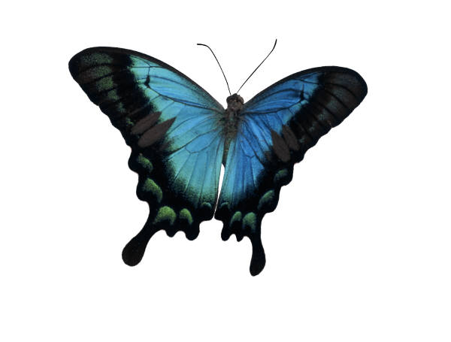

1. Which is the best unit of measure for the hairbrush? C:\Users\e200301470\AppData\Local\Microsoft\Windows\Temporary Internet Files\Content.IE5\Z32MRC8D\MC900325402[1].wmf
2. yard b. inch c. foot
3. The length of my hand is about __________________.
4. 5 feet b. 5 yards c. 5 inches d. 5 centimeters
5. The length of a dollar bill is about _________.
6. 6 centimeters b. 6 inches c. 6 feet d. 6 yards
7. How much longer is the line than the oval?



1. About how long is a football?
2. 3 feet b. 11 inches c. 20 inches D. 2 feet
3. Which of the following is the shortest unit of measure?
4. centimeter b. meter c. foot
5. John measured the length of his bed. Which is a good estimate of the bed’s length?
6. 7 meters b. 7 inches c. 7 feet

|  |
| --- |
| https://www65.studyisland.com/images/blank.gifhttps://www65.studyisland.com/userfiles/PA6rulerCam.gif |
| https://www65.studyisland.com/images/blank.gif https://www65.studyisland.com/pics/13881straw.png |

11. How long is the line shown above?

1. 1 inch B. 5 inches C. 4 inches D. 3 inches